**Touchscreen on iPhone 8 suddenly stops working? It's all because of your aftermarket screen.**



The iPhone 8 and iPhone 8s are two of Apple's most popular products right now. It's no surprise, however, that when screens shatter, fracture, or break, so many people have to replace them. People have flocked to kiosks across the country that promise to restore iPhone 8 screens for a fraction of the price of competing providers.

**What is the Reason for the Price Distinction?**

You have two options when it comes to replacing the screen on your iPhone 8. You can start by purchasing a high-quality product that is guaranteed to work with your iPhone 8. These replacement screens are typically more expensive, but they will perform identically to the screen you purchased from an Apple shop.

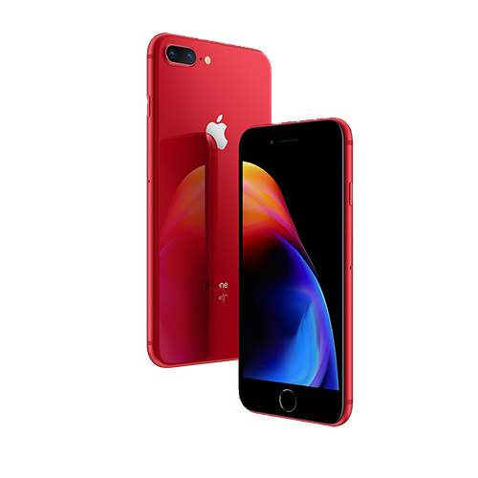

The second alternative is to have a copy or aftermarket screen installed on your phone. These screens are made to seem like Apple replacement displays, but they are of considerably inferior quality. Most mall kiosks that advertise low-cost iPhone screen replacements use aftermarket or duplicate displays, with no chance to upgrade to a higher-quality screen.

**The Problem**

When iOS 11.3 was released, several iPhone 8 customers with aftermarket/copy screens realised that their touchscreens had stopped working. They returned to the mall kiosks, frustrated, to get their screens mended only to be told that the issue was with their phone (the motherboard). Since then, headlines have appeared everywhere from Mashable to Newsweek alleging that having your iPhone 8's screen repaired by a third party will convert it into a brick if you update to 11.3 afterward.

Not true.

**The Benefits of M6 Repair**

When it comes to replacing your iPhone screen, we always provide you two options at M6 Repair. The option you select will be determined by how the device will be used after it has been repaired. If you plan on keeping your iPhone for longer than two weeks, we recommend replacing the screen with a similar-quality replacement. Not only does this screen come with a one-year warranty that covers any flaws, but it also ensures that you will not experience the same issue that so many iPhone 8 owners are experiencing right now.

We also sell aftermarket screens, dubbed "mall kiosk screens" by us. Because of the inferior quality glass, they break considerably more easily, use the battery more faster, and do not last as long as the original. This option is interesting because of its low price if you are selling or turning in your gadget to your carrier. Even so, the most recent iOS upgrade had no effect on any of the aftermarket displays carried or installed by [M6 Repairs](https://m6repairs.co.uk/). We only stock high-quality replacement components from reputable manufacturers.

Call M6 Repairs immediately for more information on aftermarket screens or to schedule your iPhone 8 screen replacement. We'd be delighted to restore your brick to functioning order.